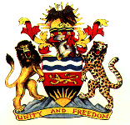
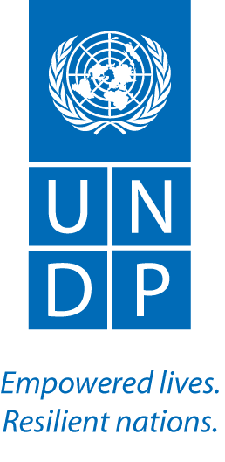

DEMOCRACY CONSOLIDATION PROGRAMME PHASE IV

PROJECT CODE: 00083040

January to JUNE, 2015 Progress Report

OFFICE OF THE PRESIDENT AND CABINET

LIST OF ACRONYMS
ADC Area Development Committee
CBF Community Based Facilitator
CDC Centre for Development Communications
CEYCA Centre for Youth and Children Affairs
CHRR Centre for Human Rights and Rehabilitation
CSO Civil Society Organisation
CRC Community Rights Committee
DAMRA Development Action for the Marginalised Rural Areas
DCP Democracy Consolidation Programme
DCT Development Communications Trust
DEC District Executive Committee
ETG Export Trading Group
GVH Group Village Headman
GoM Government of Malawi
IEC information, Education and Communication
IGA Income Generating Activity
IP Implementing Partner
IPI Institute for Policy Interaction
MGDS Malawi Growth and Development Strategy
MoV Means of Verification
MBC Malawi Broadcasting Corporation
MICE Ministry of Information and Civic Education
MP Member of Parliament
NGO Non-Governmental Organisations
PO Programme Office
PSC Programme Steering Committee
RBA Rights Based Approach
RtD Right to Development
RBM Rights Based Management
RTD Right to Development
RLC Radio Listening Club
SCF Stakeholder Consultative Forum
SMS Short Message Service
STA Sub-Traditional Authority
TA Traditional Authority
ToT Trainer of Trainers
UNDP United Nations Development Programme
UNDAF United Nations Development Assistance Framework
VDC Village Development Committee
VSL Village Savings and Loans
VCT Voluntary Counselling and Testing
YONECO Youth Net and Counselling

Executive Summary
Democracy Consolidation Programme (DCP IV) {2012-2016} is a Government of Malawi (GoM) and United Nations Development Programme (UNDP) governance programme which is aimed at capacitating the citizenry through provision of knowledge and skills to demand compliance with governance and human rights principles from duty bearers at all levels of society. The programme is cofounded by The Norwegian and Irish Governments.

This report covers the period January to June, 2015. During this period, the programme supported 15 Civil Society Organisations (CSOs) and 1 public institution to implement various activities across the country. Funding agreements with most CSOs that were supported during the previous reporting period expired on 31st December, 2014. Following a thorough assessment of the project’s programme and financial performance, thirteen projects were granted approval to extend their projects for another twelve months.
The reporting period saw the continuation of project activities in the three new districts: Balaka, Dowa and Kasungu in addition to the continuing activities in the 19 districts where the project has been under implementation. In the three new districts, the projects focused on the following preliminary activities: identification and training of Community Based Facilitators (CBFs); holding District Executive Committee (DEC) meetings and establishment of Community Rights Committees (CRCs). It is worth noting that the targeted composition of female CBFs (40%) was attained in the new districts with the exception of Dowa that could not due to low literacy levels. Membership of women in the CRCs is however almost 50%.
During the reporting period, the programme continued to strengthen the capacity of project grassroot structures namely: CBFs, CRCs and Radio Listening Clubs (RLCs) in various target districts. Through implementing refresher training sessions these grass root structures were empowered and encouraged to demand good governance, realisation of the right to development, fair trade, labour and consumer rights. The knowledge and skills gained from the various topics enabled the project structures to carry out community outreach meetings within their localities and hold dialogue meetings with duty bearers in order to resolve their local challenges pertaining to governance and the right to development. Evidence of this can be seen in the annexed success stories describing the following results: village headmen have been taken to court over corruption involving the Social Cash Transfer programmes; farmers cooperatives established and have been demand better prices for their cotton; mine workers have demanded protective gear after knowing their rights; CRCs have put in place measures to ensure that more children attend school; and HIV and AIDS clients are engaged in poultry farming, thus empowering them nutritionally as well as economically.
Monitoring and evaluation was participatory and it involved review meetings and exchange visits in selected districts that exposed project staff and beneficiaries to best practices that could be adopted. A Stakeholders’ Forum was convened to assess progress on project implementation and build consensus on some project implementation issues.
Project implementation did face a number of challenges during the reporting period. These included slow progress with implementation of project activities; underfunding of Government line ministries and District Councils and; limited governance and human rights knowledge on the supply side of service delivery. Furthermore, the flood disaster that affected 15 districts countrywide had a negative impact on the social and economic wellbeing of community members as well as on project activities. This was because in most districts, much attention was given to relief activities as well as recovery efforts. In some areas, the floods damaged roads which affected monitoring of project activities.
The main lessons learnt during the reporting period include the following: Continuous capacity building of the project structures through refresher trainings ensures improved project delivery; Evidence based advocacy provides an organization with a stronger voice and increases credibility of project delivery; Once empowered with the right knowledge and skills, low level duty bearers can ably demand essential goods and services from high level duty bearers and this results in improved public service delivery; and that there is need to continue to explore various ways of empowering women.

- Situational Background

DCP IV was designed in line with the overarching development policies namely: Malawi’s Vision 2020 and the Malawi Growth and Development Strategy (MGDS II) {2011- 2016}. The Programme falls under the governance theme of the MGDS II. DCP IV contributes to the promotion of good governance and realisation of the right to development as prescribed in section 30 of the Constitution of Malawi. DCP IV also contributes to the UNDAF whose outcome is: “National institutions foster democratic governance and human rights to promote transparency, accountability, participation and access to justice for all especially women and children by 2016”.

At programmatic level, DCP IV was designed as a response to issues highlighted in the Follow-up survey on civic education in Malawi (2011); the end of DCP III evaluation (2011); a situation analysis undertaken during the development process of the Programme; and the United Nations Development Assistance Framework (UNDAF) {2012-2016}. The Follow-up survey on civic education in Malawi revealed the need for improved knowledge and skills on governance and human rights across the country, which would require sustained efforts to cover the identified gaps. At the same time, the DCP III evaluation report uncovered the fact that efforts at creating a critical mass had largely been successful at grassroots level effectively working towards improving community and individual well-being using governance and human rights principles. However, this positive development needed to be further deepened through sustained efforts to consolidate and cover the remaining 9 districts. On its part, the situation analysis, which was done during the Programme development process, revealed that Malawi’s main problem is poverty whose root cause is the “low enjoyment of the right to development, especially amongst children, women, people with disabilities, and the rural and urban poor”.

In view of this, DCP IV aims at building the capacity of the grassroots to demand good governance and fulfilment of human rights, especially the right to development, from appropriate duty bearers. This is done through a three pronged approach namely: capacitation of grassroots communities through the transfer of knowledge and skills on governance and human rights, with special emphasis on the right to development, fair trade, labour and consumer rights using animation, group working and other interactive methods; the creation of local project structures i.e district officers, CBFs, CRCs and RLCs to lead the masses in making assessments of their community challenges and demand good governance and fulfilment of human rights, especially the right to development, fair trade, labour and consumer protection from relevant duty bearers; and provision of free paralegal services in order to facilitate access to justice for vulnerable groups. The goal of the Programme is “Group villages progressively enjoying the right to development through demanding good governance and performance of correlative duties.”

The Programme is implemented through CSOs and Public institutions that are selected through an open and competitive process. The IPs generally fall into two broad categories: district based IPs which create local structures (District Officers, CBFs, CRCs and RLCs) to lead in the community assessments of their right to development challenges and action-taking processes for the realisation of programme outputs; and media based projects which complement the district based projects through the provision of an alternative medium for right-holders to express their views and make demands to relevant duty bearers on various governance and right to development issues. The media projects also provide a readily available and efficient channel for disseminating relevant information to and sharing best practices with project beneficiaries, mostly the rural masses. DCP IV programming is guided by the Rights Based Approach (RBA) and Results Based Management (RBM). All programme activities give special consideration and priority to the status and needs of vulnerable groups.

2.0 Assessment of Programme results during the reporting period

During the reporting period, the Programme continued to provide financial and technical support to 15 CSOs and 1 public institution to implement various activities across the country.
Programme implementation during the reporting period started off at a slow pace but picked up during the second half of the reporting period. Funding agreements for most projects that were supported during the previous reporting period expired on 31st December, 2014. Nevertheless, the projects continued to implement some activities with limited resources under a no-cost extension to end February, 2015. In March, 2015, thirteen projects were granted approval to extend their projects for another twelve months. During the reporting period, projects’ activities also slowed down due to the busy farming season during which not many projects’ activities happen as project structures concentrate on agricultural activities and project monitoring is affected by slippery and impassable roads. Consequently, some activities such as trainings and review meetings were implemented towards the end of the reporting period.
The reporting period saw the continuation of Project activities in the three new districts of Balaka, Dowa and Kasungu. The projects carried out a CBF identification exercise based on the approved criteria which among other attributes focused on: maturity, literacy, credibility, gender balance, commitment and settlement within the community. 40 (10 female) CBFs were identified for Dowa district; 32 (16 female) for Balaka and 64 (30 female) for Kasungu district. In Dowa district, the project failed to reach the minimum 40 percent female composition target due to low literacy levels among women in the district. The projects also held DEC meetings which were aimed at introducing the projects and soliciting support from the members. The meetings were attended by 51 (15 female) participants in Dowa, 73 (24 female) Participants in Balaka and 45 (13 female) participants in Kasungu district. The projects were duly approved by their respective DECs and necessary guidance was provided. Chinansi Foundation (Balaka) and CHRR (Dowa) conducted Trainer of Trainers (ToT) sessions on good governance and the right to development for their CBFs. Following the ToT, the CBFs from Balaka and Dowa proceeded to establish 108 and 150 CRCs with a membership of 1208 (619 female) and 1,500 (700 female) respectively. CRC trainings in both districts will commence in the next reporting period. It should be noted that Project implementation in Kasungu district stalled following the sudden departure of the Paralegal officer who was initially hired and trained. A new Paralegal officer has since been identified and project activities are expected to pick up pace in the next reporting period. The three new projects were provided with equipment namely: 1 computer, 1 printer and a motorbike each.
During the reporting period, the Programme continued to strengthen capacity of project grass-root structures namely: CBFs, CRCs and RLCs in various target districts to demand good governance, realisation of the right to development, fair trade, labour and consumer rights. This was done through the implementation of outstanding refresher training sessions on governance, the right to development, fair trade labour and consumer rights for CBFs and CRCs in most districts as well as outstanding CRC trainings on the topics for community project structures that had either established new CRCs to cover gaps or recently moved to year 2 activities. The Programme implemented outstanding CRC trainings on governance and the right to development for 25 CRCs comprising 250 members (154 female) from Malawi CARER, Mzimba and 15 CRCs comprising 150 members (88 female) from Malawi CARER Karonga; while the following were trained on Fair trade, labour rights and consumer protection: 10 CRCs comprising 100 members (67 female) from Malawi CARER, Karonga; 13 CRCs comprising 162 members (91 female) from YONECO, Nkhatabay and; 72 CRCs comprising 720 members (387 Female) from Malawi CARER, Mzimba. 4 CRCs comprising 46 members (14 female) from WORLEC, Neno were trained on both topics. The 4 CRCs in Neno were created during the reporting period to cover some areas that were not adequately reached under the previous arrangement.
Further, 264 CRCs comprising approximately 3312 members (1661 male and 1651 female) carried out CRC refresher trainings in Nsanje, Zomba, Mchinji, Machinga, Mangochi, Ntcheu, and Ntchisi districts. The refresher training helped to revitalise the structures and provided an opportunity to revamp and monitor the work of the CRCs. The refresher training also proved very useful in as far as bringing a significant number of new members up to date with the basics of the topics is concerned as well as building consensus on the Project implementation strategy. In Zomba and Nsanje districts, the Project targeted those CRCs which were in flood camps. The reason was to encourage them to continue demanding the enjoyment of their right to development. The refresher trainings encouraged the CRCs to monitor human rights violations and to fight for the rights of the people in camps especially the vulnerable such as women, children and the elderly among others.
The knowledge and skills gained on the various topics enabled the project structures to carry out community outreach meetings within their localities on good governance, right to development, fair trade, labour and consumer rights resulting in increased knowledge on the topics. Most importantly, the communities used the knowledge and skills gained from the awareness raising campaigns to advance the wellbeing of vulnerable members of their community namely: women, children, the elderly, people living with disabilities, HIV and Aids. For instance, communities advocated for the inclusion of vulnerable groups in safety net programmes and other development activities. In light of the floods disaster, CBFs, CRCs and RLCs sensitized communities on HIV and AIDS prevention especially for those living in camps; checked abuses in the distribution of relief items as some duty bearers took advantage of the relief efforts to enrich themselves or even abuse women and the girl child in exchange for preferential treatment. Further, since the reporting period fell within the farming season in many parts of the country, efforts were made towards sensitizing communities to guard against exploitative trading practices, mostly perpetrated by middle-men, mobilize their farm produce in order to identify profitable markets and sell in groups. Efforts were also applied towards sensitizing the population on the dangers of child labour, early and forced marriages as well as consumer protection. The awareness campaigns enhanced community member’s knowledge and skills on the topics and formed the basis for the creation of a critical mass at community level.

Communities through the leadership of the project structures continued to monitor community human rights enjoyment levels and analyze their community challenges. This led them to hold dialogue meetings with duty bearers in order to resolve their local challenges pertaining to governance and the right to development. Such meetings created a platform for community members to voice out their concerns on governance and right to development issues. They also helped to iron out misunderstandings between duty bearers and rights holders and provided an opportunity for immediate feedback on issues raised. The issues discussed included enforcement of transparency in public service delivery, accessibility, acceptability and affordability of basic social services and basic services, fairness in the labour market and trading system and inclusiveness of the most vulnerable in the enjoyment of the right to development. Some of the main duty bearers that the CBFs sought audience with included officials from the District Council, Members of Parliament (MP), Councillors and CSO’s. Most dialogues yielded positive results as seen in Annex 1 and II of the report.
The media based IPs continued to produce and broadcast radio programs namely: Mbaliyanga, Mau a Kumudzi, Khamalathu, Tilondoloze Khama Lathu, Titukule Boma Lathu as well as the Mfulu Supplement in the Boma Lathu newspaper. The media projects who unlike their district based counterparts, cover the whole country complimented the efforts of grass-root based projects through the provision of an alternative channel for disseminating important and objective messages, community demands as well as feedback to project beneficiaries on good governance, the right to development, fair trade, labour and consumer rights. The media programs proved instrumental in unlocking issues with unresponsive duty bearers.
During the reporting period, grass-root based IPs in 21 districts with the exception of Kasungu continued to provide free paralegal services at district level. 1440 cases were registered out of which 836 were resolved, 375 were referred and 229 were pending. Vulnerable groups, in particular, women, children and the elderly continued to be the main beneficiaries of the free paralegal services.
During the reporting period, some IPs carried out review meeting aimed at assessing progress on project implementation and cross learning among CBFs. The meetings were carried out in Mulanje, Mwanza, Neno and Dedza districts. 98 (36 female) CBFs attended the meetings. The meetings provided valuable insights into the thrust and design of the Programme and enhanced relevant skills and knowledge among the project volunteer structure. Further, an exchange visit was conducted by 4 CBFs from TA Liwonde who visited Ntaja CRC in TA Kawinga. 86 (52 female) CRC members participated. The visit shared experiences on promotion of the right to education for children.
During the same period, The PO convened a Stakeholders’ Forum from 28th to 29th May 2015 to review project implementation and set the tone for the future. The Forum targeted Executive Directors, Project Officers, and District Managers (Paralegals) from 16 IPs. A total of 40 participants (8 female) attended the Forum. The Forum promoted cross learning, networking and collaboration among IPs and equipped them with updates on reporting, code of conduct for Project officers and CBFs, project planning and management. The PO and IPs continued to monitor project activities through reports, monitoring visits and continuous follow ups. Further, the PO was audited for the period January to December, 2014 by S.P Chopra & Company. The audit report did not reveal any major issues relating to financial mismanagement.

COLLECTIVE POULTRY FARMING TRANSFORMS LIVES OF PEOPLE LIVING WITH HIV/AIDS
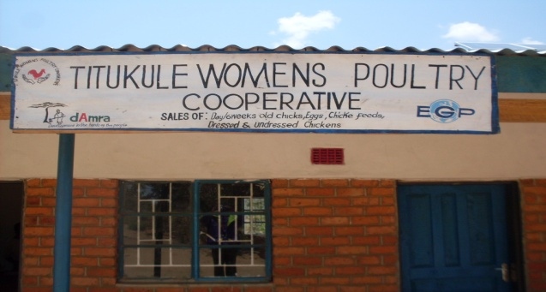
People living with HIV and AIDS from Group Village Headman Mwachirwa, Sub Traditional Authority Njikula, Rumphi have for some time lived in isolation because of the discrimination they experienced in their communities. Such people rarely actively participated in development and wealth creation activities at community as well as family levels. As a result of this vulnerability, most of them remained poor and food insecure. Due to poverty, they could hardly send their children to school.
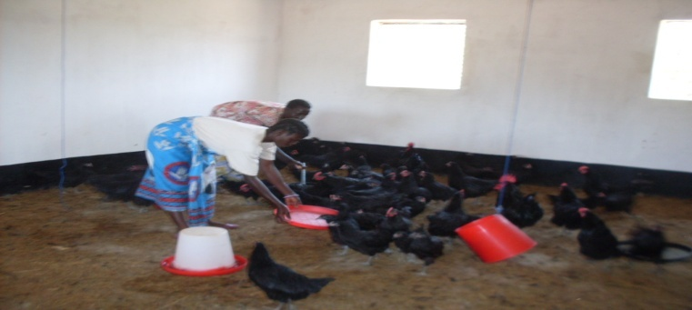
With the guidance from their Community Based Facilitator and Tiwepo CRC, these people were mobilized to form a support group for them to frequently meet and discuss how they can live positively. The CBF and members of the support group dialogued with Development Action for the Marginalized Rural Areas (DAMRA) demanding income generating activities. DAMRA accepted to support the group but advised them to mobilize themselves to work as a group. The group comprising 44 women got mobilized and agreed to embark on poultry farming. DAMRA trained the group, and supported them technically and financially to construct a poultry rearing house. When the construction was completed, DAMRA supported the group with 300 layers as seed.
Poultry House funded by DAMRA
The group started selling the eggs in January, 2015 and are currently enjoying the proceeds from this business. A part from this collective business, they are also doing individual small-scale businesses using the money they share among themselves from poultry farming. The once poor and sickly women are now nutritionally sound; their families are food secure because they can afford to feed their children. Using the proceeds from poultry rearing, they are now also able to send their children to school. The quality of life in their respective families is tremendously improving and the members are now fully participating in development work of their families and the community at large.
Women feeding their chickens

COMMUNITIES FROM GVH CHIMUTU HARA, TA MBELWA ENJOY ACCESS TO CLEAN AND SAFE WATER
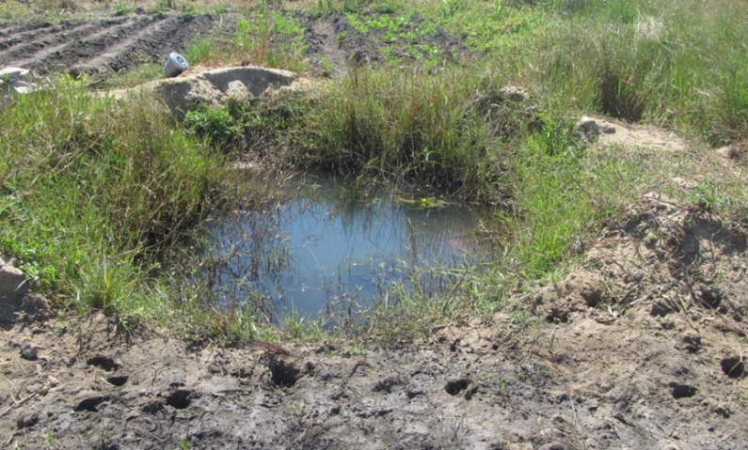
It is said that ‘water is life,’ but such was not the case for people of Juweka Mtonga and Chibo Phuwa villages in GVH Chimutu Hara, T/A Mbelwa, Mzimba. For many years, the community, with a total population of approximately 700 people were drinking water from a man-made unprotected shallow well. To make matters worse, the unprotected well they depended on was used by both people and cattle. As a result, water borne diseases such as diarrhea were the order of the day.
Armed with the knowledge and skills on the right to development, members of Mkama CRC through the leadership of their CBF were determined to change the quality of life for people in the area. The CRC discussed the matter with community members, village leaders, VDC and ADC. The meeting agreed to develop a proposal requesting World Vision to drill a borehole in each of the two villages. The proposal was accepted. In April, 2015, two boreholes were drilled to the tune of MK3.5million each.
An unprotected well where community members fetched water
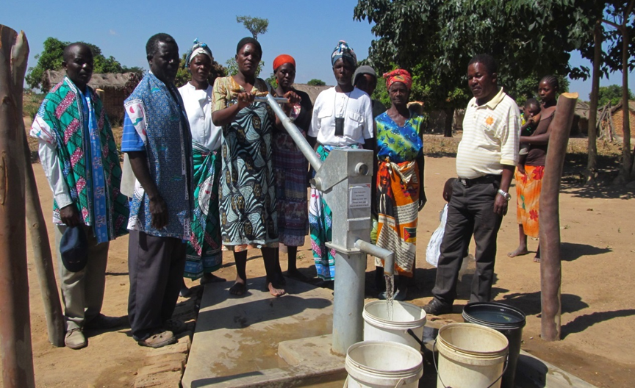
Thanks to the effort of Mkama CRC, the community members of the two villages are no longer drinking unsafe water. Waterborne diseases are a thing of the past. The people are enjoying their right to development.
One of the new boreholes. Looking on are some Mkama CRC members and women from Chibo Phuwa Village

Progress under each output
Below is a summary of progress registered under each output. Since no survey was carried out during the reporting period, in this report progress towards achievement of output targets has been determined using process indicators at CRC/GVH level which are consistent with the outputs.
Output 1: At least 70% of Group Villages in 28 districts effectively demanding progressive accessibility and acceptability of basic social services, basic services, and good governance, especially for women, youth, children and people with disabilities.
Indicators
- No. of CBFs identified and trained as trainers on governance and RBA Baseline: 0 Annual target: 136
Progress
CBF selection was completed in Balaka, Dowa and Kasungu districts. A total of 136 CBFs selected (Dowa 40, 10 female; Balaka 32, 14 female and Kasungu 64, 30 female). Following the selection, Chinansi (Balaka) and CHRR (Dowa) proceeded to train the CBFs on governance and the right to development.
Not achieved but on track. Gap: 64 CBFs (Kasungu)
- No of CRCs created and trained in three (3) additional districts of Balaka, Dowa and Kasungu. Baseline: 0; Planned: 510
Progress
Chinansi and CHRR created 108 and 150 CRCs in Balaka and Dowa respectively. The total membership of the committees is 2708 (1319 female). CEYCA is yet to establish CRCs in Kasungu. Establishment of CRCs in Kasungu and training of the CRCs in Balaka and Dowa to be done during the next half of the year period.
Not achieved but on track. Gap: Kasungu. CRCs not trained for all three districts
- No. of CRCs refresher trained on governance and RBA. Baseline 0; Annual Target 1500
Progress
The Programme implemented outstanding CRC trainings on governance and the right to development for 25 CRCs comprising 250 members (154 female) from Malawi CARER, Mzimba and 15 CRCs comprising 150 members (88 female) from Malawi CARER Karonga. 4 CRCs were created by WORLEC, Neno to cover some areas that were not adequately reached under the previous arrangement. The 4 CRCs comprising 46 members (14 female) were trained during the reporting period. Furthermore, 264 CRCs comprising approximately 3312 members (1661 male and 1651 female) carried out CRC refresher trainings on governance, the right to development, fair trade, labour and consumer rights in Nsanje, Zomba, Mchinji, Machinga, Mangochi, Ntcheu, and Ntchisi districts. The training is cumulative and has been running since last year. The refresher training will continue in the next reporting period.
Partly achieved. Gap: 545 CRCs from Ntchisi, Phalombe, Mwanza, Neno, Dedza, Ntcheu, Mangochi, Machinga, Mchinji and Zomba.
- No of CRCs/RLCs dialoguing with duty bearers in 22 districts. Baseline: 1,500; Annual target 2,000
CRCs/RLCs in 21 districts continued to make assessments and hold community sensitization campaigns on good governance, the right to development and how to demand realisation of the same from relevant duty bearers. During the reporting period, the CBFs, CRCs and RLCs carried out at least 3,342 sensitization meetings in the targeted districts reaching out to approximately 238,000 (135,000 female). The meetings enhanced the capacity of community members to effectively demand good governance, and progressive availability, accessibility, acceptability and affordability of basic social services and basic services from relevant duty bearers. As a result, 1658 out of 2471 CRCs (67%) and 59 out of 61 RLCs (97%) dialogued with various duty bearers, especially local government service providers with the aim of finding lasting solutions to their community problems.
Partly achieved
- No of cases registered and processed by the district paralegal office. Baseline: 1,600; Annual target: 2,000
Progress
During the reporting period, grass-root based IPs in 21 districts continued to provide free paralegal services at district level. 1440 cases were registered out of which 836 were resolved, 375 were referred and 229 were pending. Women continued to constitute the majority of the complainants. Generally, clients expressed satisfaction with the legal assistance rendered to them by the project offices.
Fully Achieved
- No of Radio programmes on governance and RtD produced and broadcast. Annual target: 208
Progress
During the reporting period, DCT produced 40 Khamalathu programs; 20 each were aired on MBC Radio 1 and on Capital Radio Stations. 12 Tilondoloze Khamalathu Programs were produced and 6 each were aired on MBC Radio 1 and Capital Radio Stations. CDC produced 27 Mbaliyanga programs and 25 were aired on MBC Radio 1. One program was not aired due to a technical fault at MBC while the other was carried forward to the next reporting period. The project also produced and aired 8 jingles. KKYO produced and aired 26 Titukule Boma lathu programs while Capital Radio produced and aired 52 Mau a Kumudzi Radio Programs. The Ministry of Information and Civic Education (MICE) produced and distributed 100,000 copies of the Mfulu supplement.
Partially achieved: Gap: 20,000 copies of the Mfulu Supplement. This was due to delays in identifying appropriate printing services.
Output 2: At least 70% of Group Villages in 28 district demanding fair labour practices, and markets and consumer protection especially for women, youth and people with disabilities.
Indicators
- No of CRCs trained on fair trade, labour and consumer rights in 19 districts. Baseline: 1500; Planned: 457 (initial CRC trainings); 1500 (refresher trainings).
Progress
10 CRCs comprising 100 members (67 female) from Malawi CARER, Karonga; 13 CRCs comprising 162 members (91 female) from YONECO, Nkhatabay; 72 CRCs comprising 720 members (387 Female) from Malawi CARER, Mzimba and; 4 CRCs comprising 46 members (14 female) from WORLEC, Neno were trained on Fair trade, labour and consumer rights. The training is cumulative. The remaining sessions will take place in the next reporting period.
Partly achieved. Gap: 335 CRCs (120 Karonga; 106 Mzimba; 109 Nkhatabay)
  - No. of CRCs/RLCs reporting identification and resolution of labour rights issues. Baseline: 350 Annual Target: 700
Progress
CBFs, CRCs and RLCs continued to carry out sensitization campaigns on labour rights. Issues of child labour continued to dominate the interventions. During the reporting period, at least 583 children (208 female) were withdrawn from child labour in some selected target districts. The children were involved in livestock herding, house work, fishing and farming in estates. Most of the children were enrolled back in school. Other issues that dominated grievances on labour included non-payment of overtime and poor working conditions. A total number of 315 CRCs and 32 RLCs reported to have carried out sensitization campaigns and taken action on the promotion of labour rights.
Partially achieved (Gap: 385 CRCs, 29 RLCs)
Nkhatabay, Mzimba and Karonga have not finalised capacity building of CRCs on fair trade, labour and consumer rights which will enable them to comprehensively tackle critical issues in this area.
- No. of CRCs/RLCs reporting identification and resolution of exploitative trade practices. Baseline: 500 Annual Target: 1,000
Progress
During the reporting period, the project structures continued to mobilize and motivate farmers to form collective marketing groups as a way of fighting exploitative practices by intermediary buyers. Consequently, associations were formed to facilitate group selling and identification of more profitable markets. During the reporting period 370 CRCs and 59 RLCs reported identification and resolution of exploitative trade practices.
Partially Achieved (Gap: 630 CRCs, 2 RLCs)
Nkhatabay, Mzimba and Karonga have not finalised capacity building of CRCs on fair trade, labour and consumer rights which will enable them to comprehensively tackle critical issues in this area.
- No of CRCs which reported action taking on consumer rights. Baseline: 300; Annual Target: 600
Progress
The Project structures led communities in fighting for the rights of consumers in their respective districts by among others, ensuring that traders are adhering to fair trade practices. For instance, over 65 uncertified scales were confiscated by CRCs in Ntcheu district. During the reporting period 321 CRCs and 59 RLCs reported to have taken action on protection and promotion of consumer rights.
Partially Achieved (Gap: 279 CRCs, 2 RLCs)
Nkhatabay, Mzimba and Karonga have not finalised capacity building of CRCs on fair trade, labour and consumer rights which will enable them to comprehensively tackle critical issues in this area.
- No. of CRCs/RLCs engaged in Income Generating Activities (IGAs)
Baseline: 500; Annual Target: 1000
Progress
During the reporting period, community members through the leadership of the project structures engaged in various IGAs such as bee keeping, fish farming and VSLs. For instance, through the leadership of the project structures, a total of 873 VSLs were established in Machinga district. The proceeds from such activities were mainly used to purchase fertilizer, livestock and pay school fees for their children. Some community members used some proceeds from IGAs to contribute to community projects.
During the reporting period, 440 CRCs and 59 RLCs facilitated implementation of wealth creating activities within their localities.
Partly achieved (Gap: 560 CRCs, 2 RLCs)
- No of CRCs/RLCs reporting taking action to protect rights of children and other vulnerable groups. Baseline: 500; Annual Target: 1000
Progress
The project structures remained vigilant in the protection of the rights of children and other vulnerable groups. For instance, in a bid to end various forms of child abuses such as early marriages, communities established bi-laws that ensured promotion of the right to education for the girl child. Communities also fought against abuses such as gender based violence and ensured that vulnerable groups benefitted from safety net programmes.
As a result, 467 CRCs and 59 RLCs reported to have taken action to protect the rights of children and other vulnerable groups namely, the elderly, women, and people living with disabilities and HIV/AIDs.
Partly achieved (Gap: 533 CRCs, 2 RLCs)
OUTPUT 3: No longer relevant
OUTPUT 4: Effective and efficient management, partnership formation and monitoring and evaluation of the Programme
- No of strategic partnerships facilitating the meeting of RtD demands by DCP IPs. Baseline: 14; Annual Target: 17
Progress:
New partnership were formed while existing ones continued to flourish. All IPs continued to be part of their respective DECs and other Civil Society Networks. Partnership between ground and media based IPs were enhanced and proved to be value adding.
Fully achieved
- No of Programme Steering Committee (PSC) meetings and Stakeholder Consultative Forums (SCF)
Annual Target: PSC 4, SCF 2
Progress:
No PSC meeting took place during the reporting period due to non-availability of key stakeholders. However, a Stakeholder Consultative Forum was held from 28th to 29th May 2015. The Forum targeted Executive Directors, Project Officers, and District Managers (Paralegals) from all the 16 IPs. A total of 40 participants (8 female) attended the Forum.
Partially achieved
- Funding absorption rate Annual Target: 97%
Progress
The funding absorption rate for the reporting period stood at 97%
Fully Achieved
- Established and functioning RBA and RBM monitoring and evaluation system
Progress
The PO and IPs continued to monitor project activities through reports, monitoring visits and continuous follow ups. A Norwegian delegation visited Muwalo CRC and Livulezi RLC in TA Njolomole as well as Senzani CRC in STA Tsikulamowa in Ntcheu district. Furthermore, the UNDP Programme Analyst monitored Chiyanjano, Timveziti and Tililimodzi CRCs in Mwanza, Chigwirizano and Wilisoni CRCs in Neno; Nyanjiwa CRC in Nsanje and Kajawo, Khumbulani and Ntchembere CRCs in Chikwawa district.
Further, the PO was audited for the period January to December, 2014 by S.P Chopra & Company. The audit did not reveal any major cases relating for financial mismanagement.
Fully achieved
For details of progress and selected success stories, see Annex 1 and II respectively.

- Gender mainstreaming

The Programme continued to make deliberate efforts to promote gender equality and equity at all times by ensuring that women are not only beneficiaries of project activities but that they are also active participants in the implementation of development initiatives within their communities. It is in this vein that project structures i.e CBFs and CRCs have set out to achieve a minimum of 40 percent female representation in their composition. Such was the plan during the identification of CBFs in the three new districts of Dowa, Balaka and Kasungu where 40 (12 female); 32 (16 female) and 43 (21 female) CBFs respectively were identified. In Dowa district, the project failed to reach the minimum 40 percent female composition target due to low literacy levels among women in the district.
Empirical evidence has generally shown that men have tended to monopolise resources in their general interactions with women such as monopolising proceeds realised from farm produce and such other oppressive tendencies that have ensured that women remain lower on the social ladder. In a bid to address the problem, Project structures embarked on initiatives aimed at curbing such challenges. They carried out sensitization meetings condemning all forms of violence against women and girls, stopped early marriages and mobilized community members to establish VSLs. Statistics indicate that over 70% of members of VSLs are women and the initiative has proven to be very profitable and emancipating for women. The initiative has enabled women to access capital for small scale businesses and support their families.

In appreciation of the fact that education provides the key to gender equality, the project structures have been vigilant in promoting the right to education for the girl child. Early pregnancies and marriages are some of the factors that are impeding the right to education for many girls across the country. As one way of dealing with the challenges, several communities have spearheaded the establishment of bi-laws to end early marriages and reduce various forms of abuse of the girl child. Similarly, unsuitable sanitary conditions in schools is a major cause of school drop outs among the girl child. As one way of dealing with the challenge, several communities have aggressively sought to provide adequate sanitation facilities in schools which has increased pupil retention especially for the girl child.
Women continued to benefit from and constitute a large part of the clientele accessing the free paralegal services offered at district level.

4.0 Key Partnerships

During the reporting period, District Project officers continued to participate in DEC and other district based networks such as the Primary Justice Forum, District Education Network, Court Users Committee etc. The networks enhanced coordination and information sharing among various players in the district and helped to reduce duplication of efforts.
For instance, during the national flood disaster, the projects worked hand in hand with other institutions to ensure timely rescue of people affected by floods and coordinating the distribution of relief items. Furthermore, the presence of both electronic and print media proved to be an opportunity during the flood disaster in that journalists at district level were at the fore front informing the nation and the world about the human rights violations affecting the flood victims. As a result, most NGOs such as World Vision, Goal Malawi, UNICEF, World Food Programme and Government Departments responded positively with speed.
In Mchinji district, Malawi CARER was chosen by The District Council to take part in overseeing Iron sheets and cement subsidy programme in the District. For this purpose, 15 CBFs and approximately 60 CRCs were assigned to do the selection of beneficiaries and assist with the distribution of the subsidy materials to the beneficiaries. It is envisaged that the involvement of the project structures will ensure accountability and transparency in the implementation of the safety net programmes and that more vulnerable members of the community will enjoy their right to development.
Partnerships among implementing partners have continued to prove popular and useful. There is growing collaboration between grassroots and media based partners who are increasingly relying on each other for their programming. No grassroots based structure can claim to lack access to the media whenever a need arises. The relationship is symbiotic as grassroots based IPs have a host of issues requiring sharing or unlocking through broadcast while media based projects are constantly in need of relevant material for programming.

5.0 Financial Status and Utilisation

During the reporting period, UNDP transferred to the Programme Office funds amounting to US$ 612,973 out of which US$ 594,600 was spent representing 97% delivery rate. For a detailed financial report, see Annex IV.

6.0 Lessons learnt
The main lessons learnt during the reporting period included the following:
- Continuous capacity building of the project structures through refresher trainings ensures improved project delivery;
- Evidence based advocacy provides an organization with a stronger voice and increases credibility in project implementation and that;
- Duty bearers should not be assumed have knowledge on human rights. And once empowered with the right knowledge and skills, low level duty bearers can ably demand essential goods and services from high level duty bearers which ultimately results in improved public service delivery and that;
- There is need to continue to explore various ways of empowering women as some methods such as VSLs have proven to be effective in enhancing the economic and social well-being of women.

- Challenges

- Underfunding of Government line ministries and District Councils
Underfunding of Government line ministries and District Councils continued to affect duty bearers’ timely response to the demands for improved public service delivery made by rights holders.

- The National Flood disaster
The 15 districts of the Country affected by the flood disaster included some of the project districts namely: Chikwawa, Phalombe, Rumphi, Salima, Nsanje, Zomba. Consequently, the projects had to devise ways to respond to the disaster. The floods and dry spells destroyed people’s crops and assets and forced people from their homes. This had a negative impact on their social and economic wellbeing. The situation placed a greater burden on the vulnerable members of the community such as women, child headed households and people living with disabilities and infected by HIV/AIDs. In most districts, the floods damaged roads which affected monitoring of project activities. Furthermore, Many communities as well as project structures in districts that are prone to flooding as well as others that experienced flooding earlier this year, are yet to return or will not be returning to their original homes. This has disrupted project activities significantly.

- Busy Farming Season

Project activities generally slowed down due to the busy farming season which took community members away from project related activities. Consequently, some project activities such as training and review meetings were postponed to the next reporting period.

- Limited governance and human rights knowledge on the supply side of service delivery

There is a knowledge mismatch on issues of governance and human rights between the demand and supply sides with the demand side being way ahead of the supply side. This is creating unnecessary misunderstandings and conflict. Some delays in response times by the duty bearers can also be said to be emanating from this.

8.0 Conclusion
In spite of the challenges detailed above, project structures and their communities remained vigilant in addressing community challenges pertaining to their right to development. This resulted in improvement in their well-being as well as that of the vulnerable members of their community.
The Programme demonstrated its relevance in addressing the challenges outlined in the situation analysis. It also demonstrated that it was an enabling tool for the attainment of Vision 2020, theme 5 of MGDS II and Outcome 4.1 of the current UNDAF.

-----------------------------------

Chitipa, Likoma, Kasungu, Lilongwe, Dowa, Balaka, Blantyre, Thyolo, and Chiradzulu.
For list of supported institutions see Annex III

